**Declaration**

We hereby declare that the project work presented in this report entitled **“Fake Social Media Profile Detection”*,*** in partial fulfillment of the requirement for the award of the degree of **Bachelor of Technology in Computer Science & Engineering**, submitted to Dr. A.P.J. Abdul Kalam Technical University, Uttar Pradesh, Lucknow is based on our own work carried out at Department of Computer Science & Engineering, G.L. Bajaj Institute of Technology & Management, Greater Noida. The work contained in the report is true and original to the best of our knowledge and project work reported in this report has not been submitted by us for award of any other degree or diploma.

Signature:

Name: Vaidehi Kumari

Roll No: 2101920100315

Signature:

Name: Upasana

Roll No: 2101920100310

Signature:

Name: Dinesh Kushwaha

Roll No: 2101920100108

Signature:

Name: Harsh Choudhary

Roll No: 2101920100121

Date:

Place: Greater Noida

## Certificate

This is to certify that the Project report entitled **“Fake Social Media Profile Detection” done by Vaidehi Kumari (2101920100315), Upasana (2101920100310), Dinesh Kumar Kushwaha (2101920100108) and Harsh Choudhary (2101920100121)** is an original work carried out by them in Department of Computer Science & Engineering, G.L. Bajaj Institute of Technology & Management, Greater Noida under my guidance. The matter embodied in this project work has not been submitted earlier for the award of any degree or diploma to the best of my knowledge and belief.

Date:

##### Mr. Kuldeep Singh Dr. Sansar Singh Chauhan

**Signature of the Supervisor Head of the Department**

**Acknowledgement**

The merciful guidance bestowed to us by the almighty made us stick out this project to a successful end. We humbly pray with sincere heart for his guidance to continue forever.

We pay thanks to our project guide **Mr. Kuldeep Singh** who has given guidance and light to us during this project. His versatile knowledge has helped us in the critical times during the span of this project.

We pay special thanks to our Head of Department **Dr. Sansar Singh Chauhan** who has been always present as a support and help us in all possible way during this project.

We also take this opportunity to express our gratitude to all those people who have been directly and indirectly with us during the completion of the project.

We want to thanks our friends who have always encouraged us during this project.

At the last but not least thanks to all the faculty of CSE department who provided valuable suggestions during the period of project.

**Abstract**

The rapid progress of fake profiles on social media platforms poses a significant challenge, contributing to the spread of misinformation, cyber fraud, and malicious activities. This project aims to design a robust system for detecting fake social media profiles using machine learning techniques and behavioral analysis. By leveraging a combination of profile metadata, activity patterns, network features, and linguistic analysis, we identify distinguishing characteristics between genuine and fake accounts.

The system employs supervised and unsupervised learning models, alongside deep learning techniques, to analyze and classify profiles with high accuracy. Key features such as account age, friend-to-follower ratios, posting frequency, and content sentiment are extracted and used for model training. The detection framework is evaluated on publicly available datasets and real-world data, achieving promising results in terms of precision, recall, and overall efficiency.

The final deliverable is a scalable web-based tool capable of processing profile data and providing real-time detection. This project not only highlights the growing need for automated solutions to combat online deception but also provides a foundation for future advancements in detecting sophisticated fake profiles.

**Table of Content**

Declaration…………………………………………………………………………………...(ii)

Certificate…………………………………………………………………………………....(iii)

Acknowledgement…………………………………………………………………………...(iv)

Abstract………………………………………………………………………………………(v)

|  |  |  |  |
| --- | --- | --- | --- |
| **Chapter 1.** | | Introduction……………………………………………………………… | 8 |
| 1.1 | | Preliminaries…………………………………………………………….. | 8 |
| 1.2 | | Problem Statement ……………………………………………………… | 10 |
| 1.3 | | Motivation……………………………………………………………….. | 11 |
| 1.4 | | Objectives ………………………………………………………………. | 12 |
| **Chapter 2.** | | Literature Survey………………………………………………………... | 13 |
| 2.1 | | Introduction ……………………………………………………………... | 13 |
| 2.2 | | Related Work……………………………………………………………. | 14 |
| 2.3 | | Research Gap……………………………………………………………. | 18 |
| **Chapter 3.** | | Proposed Methodology………………………………………………….. | 19 |
| 3.1 | | Introduction ……………………………………………………………... | 19 |
| 3.2 | | Problem Formulation …………………………………………………… | 21 |
| 3.3 | | Proposed Work …………………………………………………………. | 23 |
| **Chapter 4.** | | Implementation………………………………………………………….. | 25 |
| 4.1 | | Introduction …………………………………………………………….. | 25 |
| 4.2 | | Implementation Strategy.……………………………..…………………. | 27 |
| 4.3 | | Tools/Hardware/Software Requirements..……………………………… | 31 |
| 4.4 | | Expected Outcome ……………………………………....……………… | 34 |
| **Chapter 5.** | | Result & Discussion……………………………………………………... | 36 |
| **Chapter 6.**  **Chapter 7.** | | Future Scope……………………………………………………………..  Conclusion……………………………………………………………….  References……………………………………………………………….. | 41  42  43 |
|  |
| **List of Figures and Tables**  **Figure 4.2.1**  Importing modules…………………....................................................26    **Figure 4.2.2** Data handling ..................................................................................27  **Figure 4.2.3** Setup for model training .................................................................28    **Figure 4.2.4** Confusion matrix..….......................................................................28    **Figure 4.2.5** ROC curve……...............................................................................29    **Figure 4.2.6** Correlation heatmap.........................................................................29    **Figure 4.4.1** User data and user account...............................................................33    **Figure 4.4.2** ROC curve........................................................................................33    **Figure 4.4.3** Assumptions on logistic regression..................................................34  **Figure 4.4.4** Final output…...................................................................................34 | | |  |

# Chapter 1

## Introduction

## 1.1 Preliminaries

In order to proceed with the design of a false social media account detection system, one has to understand the problem space, derive the useful features, and analyze previous methods. Based on this first work, a robust and efficient detection system is constructed.

1. Literature Review Research on Fake Profiles: Read up on latest research about how fake profile behave, how they are created and what reasons exists for making them. Detection Techniques Early detection of deceitful profile based on pre-defined rules like age of the accounts and their activity levels. Applied classification algorithms on the profile analysis. Weaknesses of Existing Methods: This is inability to adapt or adjust to new strategies applied to harmful players. Unnecessarily high false-positive or false-negative rates in certain systems. Limited generalizability to other social networking websites.

2. Data Sources Datasets: Raw public data such as this "Fake Profile Detection Dataset" (from Kaggle or the like). Web-scraped data from websites like Twitter, Facebook (legal and ethical limitations). Features Identified: Account creation date, profile picture presence and username attributes are Profile Metadata. Behavioral characteristics include frequency of posting, ratio of followers vs those folks you follow, and the pattern of engagement. Features of the content: linguistic sophistication, application of spam terms, and sentiment analysis.

3. Feature Engineering Inferring useful characteristics from a set of data which are useful for distinguishing between valid and spurious profiles. Finding: Account age, number of friends and follower/following ratios. Activities that have irregularity occurring, such as over posting over short intervals. Patterns such as previous or promotional posts.

## 4. Selection of Models Algorithms selected for round-one evaluation: Logistic Regression, Random Forest and Gradient Boosting of Supervised Learning. Unsupervised Learning: Clustering (e.g., K-Means) for anomaly detection. With Regularisation and without regularisation.

## 5. Tools and Frameworks The libraries that I used: Python programming, Pandas, NumPy, and Scikit-learn. Machine Learning: TensorFlow or PyCharm for sophisticated modeling. Visualization: Matplotlib and Seaborn for data interpretation. It needs a mechanism to store the data, that is – MySQL or MongoDB to manage the dataset.

## 1.2 Problem Statement

It has become a massive problem on social networking websites as fake profiles are overspread everywhere, for example becoming an organized business fulfilling the large amount of fakes with great ease and with less cost, contributing to the spread of a wide variety of illegitimate activities like spreading misinformation, identity theft, phishing, spam and social engineering scams, etc. These fake profiles usually appear as legitimate users and it is hard to differentiate from real users using basic means, such as manual moderation or rule-based detection models. The situation is worsened by the fact that the increased level of sophistication of the fake profiles enables them to modify themselves to escape existing mechanisms of detection. In addition to compromising and jeopardizing security and confidence of the social networking sites and the users themself, companies and society overall are put in danger by this problem. The necessity of having a system to effectively identify spurious profiles, be scalable, automated, and correct with data on social sites growing continues.

The central problem that is the solution of this research is to differentiate between real and fake profiles through the use of machine learning and data driven methods. Based on user behavior analysis, profile metadata network links and content features, the proposed system will be able to identify the spurious accounts with high accuracy.

## 1.3 Motivation

## This has revolutionized how we communicate with the world, and yet it has presented a challenge, one very challenging one that is, one of which is the use of fake profiles. The use and creation of fake profiles has much more than social platform impacts, such as economic scams, loss of trust, and destruction of society. The ones listed below are the most critical considerations when it comes to initiating this project.

## Maintaining User Privacy and Security

## Mostly, the phony profiles are put to use in the social engineering, impersonation, and phishing attacks to obtain the users’ financial or personal information. This method helps to prevent the users or safenctate the users from these profiles.

## Combating Deception and Disinformation

## Most of the time fake accounts are used to spread false information, control the public opinions, and carry out scams. Such ill intentions can be mitigated with a good detection system that can identify and hinder the spreading them.

## Enhancing Platform Integrity

## User’s trust and confidence on social networking sites are the key factor for the viability and success of social networking sites. They help improve credibility of the site and turn into secure, the true users’ community. Real World This problem is not limited to the domain of cybersecurity, cyber governance and digital identity management. Such a project can help organizations, governments, and people create their online space safer by helping creating an effective detection framework.

## 1.4 Objectives

What this is aiming is very simple: to build and deliver a reliable system of fake social media account detection using machine learning and behavioral analysis. The specific objectives are:

1. Identify Key Features: For instance, from metadata, user actions, network behavior and content, extract indicative characteristics of scam profiles.
2. Develop a Machine Learning Model: Develop supervised and unsupervised machine learning models to train and develop profiles based on their legitimacy or fake with high precision.
3. Enhance Detection Accuracy: The next step is to select suitable features to improve the model’s performance as well as to eliminate false positives/negatives to improve overall generalizability on other platforms.
4. Evaluate the System: Using public data sets as well as the actual data, check the system’s effectiveness in terms of precision, recall, F1 score, ROC – AUC.
5. Create a Scalable Framework: Create a solution that can manipulate big data and change in the creation of impression profiles.
6. Implement a user friendly interface: A web based software or dashboard system to input profile information of the users and present real time detection outputs.
7. Implement Wider Intended Uses: Understand the wider intended uses of data beyond initial collection, avoidance of unauthorized users and excessive data retention.

# Chapter 2

## Literature Survey

## 2.1 Introduction

Expansion of spurious profiles over the online social networking sites is a serious ordeal in ensuring individuals cyber security, security of platform legitimacy and general cyber security. The spread of misinformation, phishing, identity theft and financial fraud are critical problems (of the form) in the form of spurious profiles, mostly created with ill intent on intentionally deceptive or harassing behaviour. As with increased extent and complexity of such spurious account, conventional detection approaches such as manual monitoring or simple rule based technique are not working and inadequate.

To tackle this problem, many methods have been described in the literature to find the fake social media profiles. The methodologies span from rule based to machine learning, to network analysis and deep learning based methods, very recently. On the other hand, each of these techniques has intrinsic strengths and weaknesses, and significant progress has been made in the identification of spurious profiles efficiently, scalably, and with accuracy in far too many aspects of the problem. The literature review focuses on collecting the body of literature researching and current on fraudulent profile detection in the attempt to consolidate this knowledge to serve as a review of the most important of methods, technology used, and research applied in the creation of this project. Specifically, they include traditional detection systems, machine learning algorithms creation, techniques of content analysis, and network analysis of detection of fraudulent profiles. Hybrid approaches that combine more than one technology are also covered, where the strength of each approach is used to complement it.

In this way, these methods being used today are examined and the remaining limitations and problems in this field are understood, and lead to the solution proposed. The objective is to glean lessons from these outputs and build a sharper, more adaptable and competent system of distinguishing false profiles on social media to serve all such platforms facing the effects of a continuously evolving set of fake profiles.

**2.2 Related Work**

This is an interest for researchers across many different fields, including machine learning and data mining, as well as cybersecurity and social network analysis, but their focus has been on fake social media profile detection specifically because the subject is so poorly researched. In this section, there are significant research, methods used, strengths and weakness of methods and contributions to the study of fake profile detection.

1. Rule-Based Approaches

The rules of detection were rule based, implying that simple rule based systems were used (defined conditions and thresholds) to look for suspicious accounts.

2. Machine Learning-Based Detection

In order to find spurious profiles, supervised learning algorithms have become more and more popular in machine learning, as they learn patterns in labeled data sets.

3. Deep Learning Methods

As deep learning is making a comeback in the recent years, most of the researches on detection rely on neural networks and various other deep models to enhance detection accuracy and handle large datasets.

4. Undeniably

Network Analysis Based Detection has been utilized by social network analysis to identify spurious profiles based on the user’s relationships and the structure of the network. Many spurious profiles exhibit characteristic network profiles, such as disconnected clusters, odd ratio of followers and followers, etc..

|  |  |  |  |  |  |
| --- | --- | --- | --- | --- | --- |
| **Author** | **Year** | **Approach** | **Techniques used** | **Key findings** | **Limitations** |
| **Benevenuto et al.** | 2010 | Rule-Based Approach | Profile feature analysis (e.g., friend count, activity level) | Identified fake profiles on Facebook using feature-based rules | Limited to Facebook; unable to detect advanced bots |
| **Yang et al.** | 2013 | Machine Learning (SVM, Random Forest) | Supervised learning models, feature selection | Used supervised learning on metadata like user activity to detect fake profiles | Focused only on profile data, may miss behavioral patterns |
| **Cresci et al.** | 2015 | Network Analysis | Graph-based analysis, community detection | Leveraged social network analysis to detect fake profiles based on interaction patterns | May not generalize well across different platforms |
| **Kumar et al.** | 2014 | Behavioral Profiling | Behavioral data analysis, classification algorithms | Applied behavior-based profiling for fake account detection | Requires significant behavioral data, platform-specific |
| **Ruchansky et al.** | 2017 | Deep Learning | Convolutional Neural Networks (CNN), RNN | Used deep learning to classify fake vs real accounts based on content and interaction | Heavy computational requirements, overfitting risk |
| **Ahmed et al.** | 2020 | Hybrid Approach | Machine learning + network analysis | Combined machine learning models with network analysis for enhanced accuracy | Complexity of the hybrid model may hinder real-time detection |
| **Zhao et al.** | 2018 | Natural Language Processing (NLP) | Text mining, sentiment analysis, neural networks | Focused on using NLP to detect fake profiles based on content analysis | Reliant on textual data, not applicable for image-based platforms |
| **Liu et al.** | 2016 | Feature Engineering + Machine Learning | Logistic regression, Naive Bayes | Developed a hybrid model using content features and machine learning algorithms | Focused on limited feature set; accuracy varies with platform |
| **Ruchansky et al.** | 2018 | Time-based Analysis | Time-series analysis, recurrent neural networks (RNN) | Proposed real-time detection of fake accounts based on activity timestamps | Requires frequent updates, can be computationally intensive |
| **Ghosh et al.** | 2016 | Classification with Social Context | Random Forest, Profile characteristics | Combined user profile data with network structure to improve fake account detection accuracy | Could have biased results if user profiles are incomplete |
| **Wang et al.** | 2019 | Hybrid Deep Learning | CNN, Long Short-Term Memory (LSTM) | Developed a deep learning-based model to detect fake profiles using both behavioral and content data | High computational cost for large datasets |

**Table No.** - 1

The fake profile detection and the fine work related to it use various techniques such as machine learning, deep learning, and network analysis. Nevertheless, problems of quality of the data, scalability, model transparency and ethical concerns persist. Taking advantage of the strengths of these approaches, in particular hybrid models, this work will develop a robust, accurate, and ethically compliant solution to fake social media profiles using this project.

**2.3 Research Gap**

The novelty and the significance of a project need to be identified by the issue of a research gap. Here are some gaps in the research that can be detected in the detection of spurious social profiles: There is a Lack of Real World Data: Most of the previous work is based on the data simulated or on small datasets that cannot well represent social media interaction, which is rich and dynamic. More generalizability to real world data sets is needed from research based on large scale detection models that capture the large scale behavior of state routing. Strategies of Fake Accounts Are Changing: Social Media Plays and how fake accounts use them are changing as platforms continue to do the same thing. Emerging tactics used by malicious users might not necessarily be sensed by present detection techniques. To adapt to new trends, adaptive algorithms are needed to be learned 'on the go', to continuously improve the methods of detection as they are. Most of the research available so happens to be for one social network platform. Very few research attempts have been made for the study of the fake profile trends over all the platforms (Facebook, Twitter, Instagram) for the identification of the universal patterns and behavior to be employed in improving the detection techniques. Though almost all the work is applicable to text data, there are no good ideas for multimodal data integration (images, videos, user interactions). Research based multimodal data integration is also capable of producing more accurate and complete detection schemes. Current models have almost nothing to say about the influence of user behavior and contextual factors (cultural differences, platform specific norms) as determinants of impact of authenticity in profiles. This can help to discover these factors and this may explain why people use fake accounts and how methods to detect them can be improved.

# Chapter 3

## Proposed Methodology

## 3.1 Introduction

Social media platforms have become an urgent issue when it comes to the detection of fake profiles as they can become more and more sophisticated and on a larger scale. The Chief Information Security Officer (CISO) of the Twittershock discussed the dangers to the security, privacy and provider of trust by fake accounts to the platform with NBC News. However, existing methods including rule based and traditional machine learning have limitations for high numbers of users and ways in which a fake profile creator evolves. In addition, most of the ones available lack the adaptability and generalization needed to work with various social media platforms.

In dealing with these challenges, the proposed methodology takes a hybrid approach trying to utilize several advanced technologies in a mutually synergistic way for a more effective, scalable, and adaptive fake profile detection. The model idea is to build a network analysis and machine learning combination that helps identify fake profiles with very high accuracy, be interpretable and scalable.

Major aspects of the proposed analytical strategy include the following points:

The process includes data preprocessing which involves the collection of big social media data including user profiles and activity logs and social interaction logs obtained from different sources.

The detection process requires performing preliminary data cleansing operations to obtain important features which help recognize fraudulent profiles. The detection process retrieves the most vital features from user data containing elements such as profile completeness alongside number of friends and posting frequency with content category and social graph connections and interactions.

The Hybrid Model Structure combines different strategies to develop a resilient detection system. The hybrid model suggested is:

A set of supervised models (including Random Forest and Regularisation along with others) serve as the initial classification mechanism based on extracted features.

A training process for the model occurs through labeled data sets that contain both real and synthetic profiles during which cross-validation methods prepare the model to analyze previously unseen data. A testing process will evaluate the model to reduce both false positive and false negative identification outcomes.

The system will deploy the model to detect suspected fraudulent profiles at the instant of profile creation or use within its platform. The system needs to optimize rapid prediction speeds without sacrificing performance standards.

The model seeks to achieve interpretability together with its accuracy goal. The system will employ explainable AI methods to provide explanations about the recognition basis for each identified counterfeit profile.

This combined system incorporates multiple detection techniques to handle fictitious profile volatility with a budget-friendly approach and safe delivery of efficient detection procedures. The new model will prove its superiority to present systems while showing its ability to discover false profiles at large volumes using low processing power.

**3.2 Problem Formulation**

The detection of spurious social media profiles operates as a classification task that requires assessing whether profiles belong to one of two categories: genuine or spurious. The detection process should target suspicious profiles that contain specific indicators that match those known to belong to bots and spammers as well as impersonators. The resolution of this problem involves following steps:

1. Data collection Problem formulation requires collecting extensive data from various social media platforms during its initial phase. Data includes:

Time-scale data encompasses profile images together with the number of friends, audience information and elapsed time since creation and the profile completion percentage.

User interaction information incorporates all destructive activities from commenting to sharing activities in addition to social media user engagement metrics. Social Graph Data: Followers/friends, connections, and the user's social network structure. Instruction: The written texts of social media posts together with all digital media content including posts comments and images and videos and links represent the content data. Relevant classification needs to follow the data set by marking authentic profiles and bogus ones through manual inspection combined with a rule-based approach or expert verification methods.

2. Feature Extraction

Obtaining informative features becomes essential after data collection for discriminating real profiles from fake ones. Features are categorized into:

The permanent features of profiles are known as profile features which contain:

Number of followers/friends

The completeness of profile indicates whether every available field contains data.

Profile features include the account age measurement that represents the length of time since when the account became active.

Availability and authenticity of profile picture

The characteristics that describe user behavior patterns fall under this category since they represent active features which change over time.

Frequency of posts and comments

Users can post different kinds of material through their profiles such as pictures texts and links.

Users spend between encounters for posting interval and commenting activity.

The degree to which an account interacts with others is measured through comment participation and following implementation alongside response occurrences.

The evaluation considers the patterns of relationships between users and their network participation.

Number and quality of friends or followers (actual users vs. dubious users)

Cluster and community structures of the social graph

The analysis focus on sudden changes within user network interactions together with their connections (e.g. rapid friend requests and social media actions)

The model training process begins after applying normalizations to data filtered from raw information sources to handle missing values.

3. Model Training and Design

Building the model serves as the fundamental task to identify genuine profiles versus fake ones through the generated feature. The model must deal with:

Fake accounts exist in significantly lower numbers compared to actual user accounts. Data balancing methods are required to address class imbalance since the data set needs either oversampling or undersampling or cost-sensitive learning.

Mixed types of features from interactions profiles and networks emerge during the extraction Both textual and numeric and categorical inputs are shown together throughout the process. The compatibility of machine learning algorithms depends on correct data coding methods that precede data input into algorithms. There are three steps to classification enabled by supervised models of learning:

Decision Trees serve as tools for hierarchical decisions that rely on feature values.

Random Forests: A combination of decision trees for improved generalization.

A classification model named Logistic Regression functions for targets that have binary form (Fake (1) against Not Fake (0)) depending on data availability.

4. Real-Time Detection

The model needs to undergo real-time deployment after its completion of training.

**3.3 Proposed Work**

The research proposed is to integrate machine learning methods and network analysis software utilities along with behavior profiling frameworks for the purpose of identifying fraudulent social network profiles using such an integrated dual detection system. The spurious profile detection technology is developed to have accurate results with few false positives and false negatives, in the context of the development processes. Then, the solution combines three plaintext components of profile data and behavioral traits and social network data points into a single system where graph networks are analyzed by deep learning methods and features are engineered. The Most Critical Ingredients of the Proposed Project Data Collection and Preprocessing For model operations in different social networks, the data collection system collects the data from Twitter and Instagram and Facebook social networks. The profile surveillance system monitors two different types of profile features, which are long term features such as account age and friend connectivity distance and short term features of showing user productivity and extent of posting. In other words, logged records, such as content creation, post comments, content sharing behavior by users, are monitored for abnormal user activity patterns that will be further analyzed for system surveillance. Research core is built from social network features, core of which consists in connecting with friends and followers, automatic account and fake profile identification.

Key Profile Based Features of the users include presence of profile photo, completeness of the profile, age of the account and count of the followers/friends. These attributes are used to detect very incomplete profiles or profiles with strange pattern. Training of the Model on the user uploaded resources such as text, images, videos and determining the probability of the profile being a fraud. Such features include NLP based features, for example, text similarity, sentiment analysis, anomalous content pattern (e.g. spam content). The behavioral features include the frequency of posts, posting time interval and variability in posting pattern. Spurious accounts are those which show too high or too low a rate of posting than what might be typical. Features of the network: Disconnected nodes, tight clusters of nodes, network activity (e.g., user interaction with other users), when it comes to detecting anomalies (i.e. presence of bots). The model combines a list of methods of detection to take advantage of each one: Machine Learning Models From extracted features, profiles are to be predicted with the use of Regularisation and Random Forests so as to predict these profiles as not real or real. The models are able to handle the number of features in a dataset that is very complex, and work across multiple platforms. Logistic Regression will also perform the binary class prediction as well as feature selection as it shows how class labels are related to features in it. Deep Learning Models After posts and profile images attached to contents we will be using Convolutional Neural Networks (CNNs) to scan for evidence of fake content (image taken from photo shop or stock). All the sequential data such as comments, posts and long term user behaviour will be processed using Recurrent Neural Networks (RNNs). This is very appropriate for detecting spammers' anomalous patterns of posting, and bursts of activity. The analysis tool will process social network data through graph-based mathematical formulas. The Louvain method helps us locate groups of spam accounts or groups that suggest online fraud through automation or coordinated schemes. Link prediction methods will show how users connect with each other on the network to check if this linking model matches real life social networks.

Model Optimization and Training

We teach our system by using labeled data that consists of real customer profiles combined with synthetic profiles. We will prepare our data and transform its features to help our model better detect essential information.

# Chapter 4

## Implementation

## 4.1 Introduction

## The proposed task involves machine learning pipeline development for structured data imitation social media account detection. The implementation includes:

## The first step involved viewing patterns while discovering missing values and understanding data relationships in the data exploration phase.

## Categorical features will be encoded while numerical features will be scaled and procedures will handle missing values in the preprocessing phase.

## The feasibility of logistic regression has been increased by performing GridSearchCV hyperparameter optimization training.

## The testing phase utilizes three assessment metrics namely AUC-ROC and classification reports coupled with confusion matrices.

## The system generates three types of visualizations that include heatmaps and pair plots together with ROC curves.

## The implemented framework delivers an adaptable system for spurious account detection with both precision and readability in mind.

## A collection of machine learning and deep learning models receive extracted features for the purpose of determining whether user profiles represent genuine accounts or not. Several models among them Random Forests alongside neural network architectures form part of the selection.

## Training models will use validated dataset with cross-validation to ensure models achieve sufficient generalization and prevent overfitting of results.

## 4.2 Implementation Strategy

**1. Module Imports**

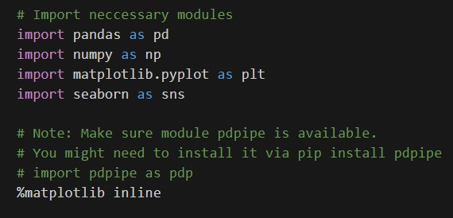

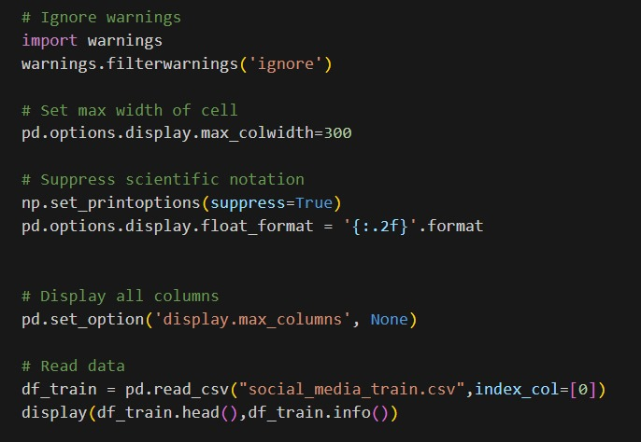

**Fig 4.2.1 -** Importing modules

**2. Load and Explore the data**

During this step the dataset entry method explores both structural aspects and content elements. The important activities are:

The data loading process with pandas also includes any available data dictionary as contextual information.

I checked the data dimensions together with column names and data types while inspecting the initial rows.

The percentage of null data values from each column serves as the basis for understanding the missing information.

•Summary Statistics: Verifying the presence of numerical data distributions (e.g., mean, range) and distinct values in categorial columns.

The dataset becomes ready for further processing because this phase shows both its organization information and potential problems that exist.

3. Data Preprocessing

•Categorical and Numerical Columns

•Feature Engineering: Label Encoding

•Manage Missing Data

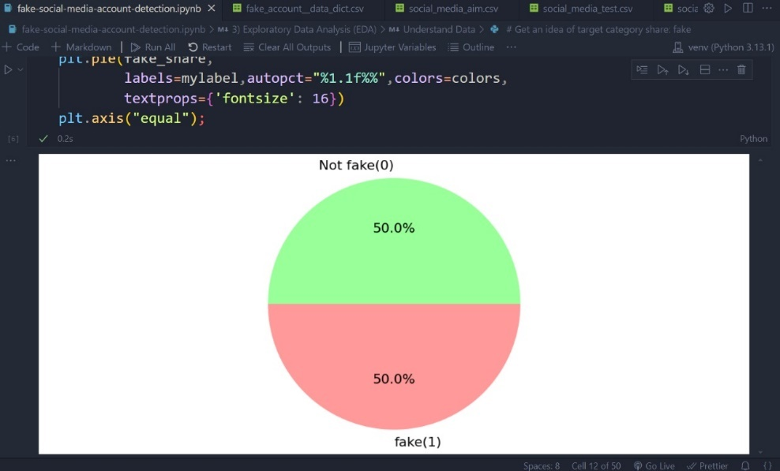

**Fig 4.2.2** – Data handling

**4. Model Training Setup**

* Split Data
* Pipeline and Grid Search

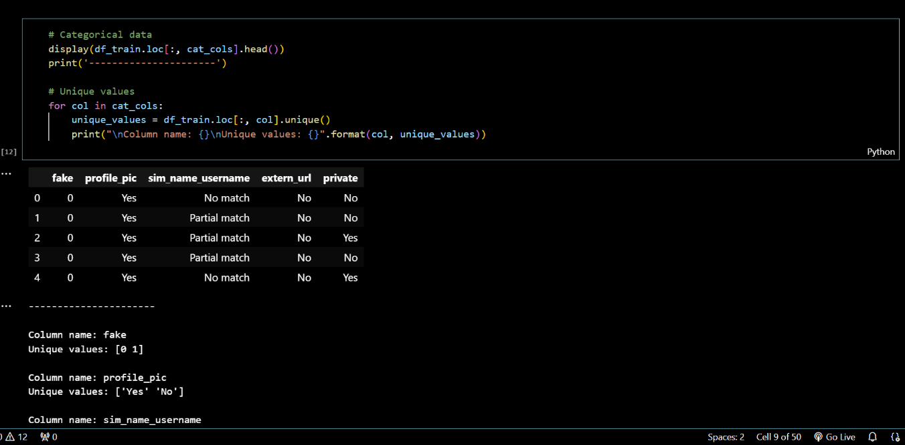

**Fig 4.2.3** – Set up for model training

**5. Model Evaluation**

* Classification Report and Confusion Matrix

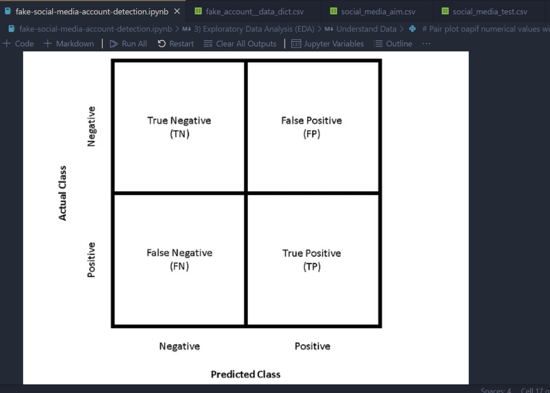

**Fig 4.2.4** – Confusion matrix

* ROC Curve and AUC Score

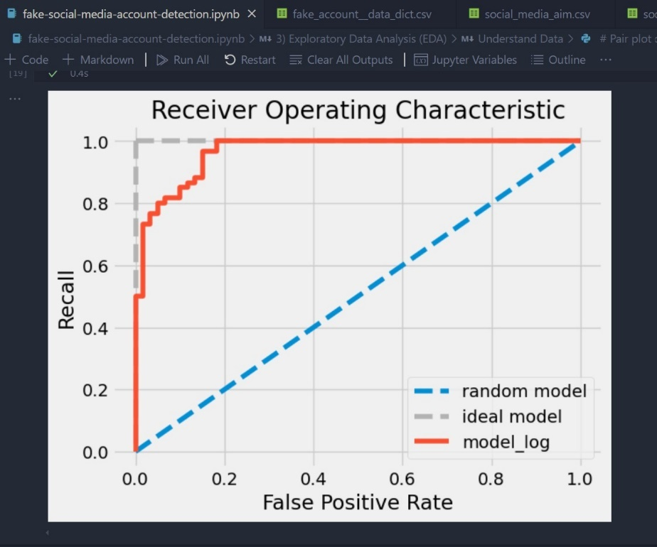

**Fig 4.2.5** – ROC curve

**6. Visualization of Results**

* Pair Plot for Numerical Features
* Correlation Heatmap

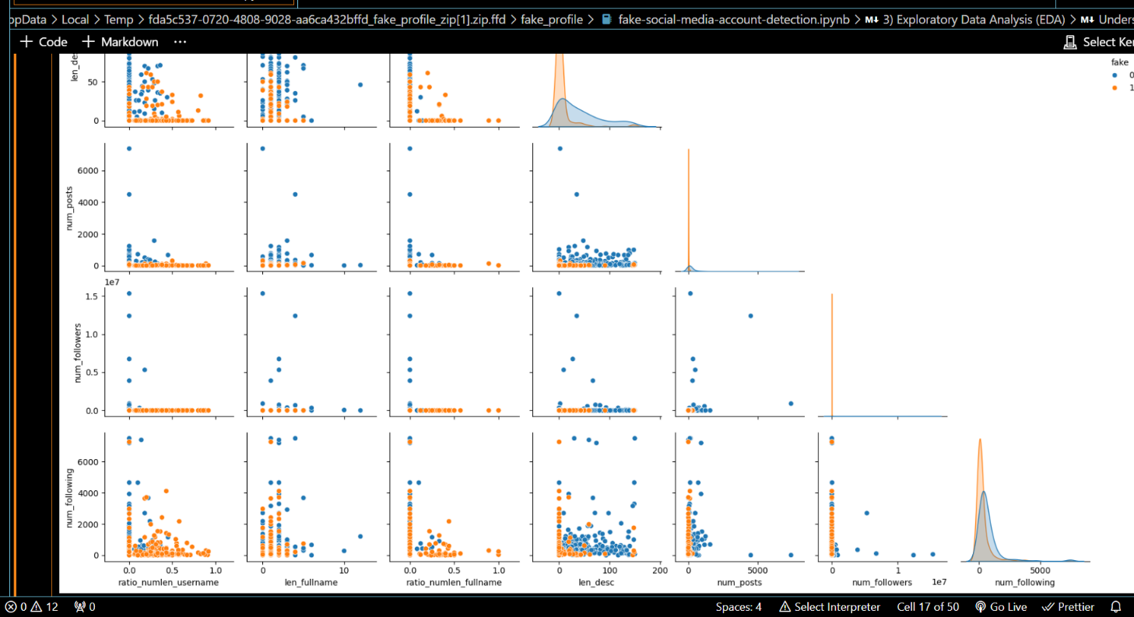

**Fig 4.2.6** – Correlation Heatmap

**7. Summary**

The roll-out comprises:

• Data preprocessing and loading.

The sequential data manipulation includes encoding categorical variables together with handling missing values.

• Grid search training of pipeline logistic regression model.

• AUC-ROC and classification metric verification of the model.

We need to establish the relationships present inside the data collection.

Additional preprocessing together with ensemble or cross-validation methods can be included to extend the pipeline when meeting specific project needs.

**4.3 Tools/Hardware/Software Requirements**

**1. Software Requirements**

1.Python

Python functions as the fundamental programming language which serves for all data analysis and machine learning as well as graphical representation needs.

Version: 3.10 or higher

a.Libraries/Packages:

i.pandas: Data manipulation and analysis.

ii.numpy: Numerical computation.

iii. matplotlib and seaborn: Data visualization.

Machine learning models and metrics which scikit-learn offers to users form an important part of its collection.

v.warnings: Warnings management in the environment.

vi.pip for package management.

2.IDE/Editor:

A user needs either an Integrated Development Environment (IDE) or a code editor that enables Python development along with running Python code.

a. Jupyter Notebook: Perfect for interactive coding, data visualization, and exploration.

b. VS Code or PyCharm: Python general-purpose development editors.

3.Version Control:

a. The version control system Git manages both code updates and enables teamwork.

b. Users can find GitHub/GitLab platforms as their choice for code repository and collaboration needs.

2. Hardware Requirements

1.Processor:

The system requires a multi-core processor based on Intel i5 or later series or equivalent AMD architecture to perform automatic computational processes mainly during model training operations. The program requires a minimum of 8GB but users will experience better performance with 16GB RAM up for big data analysis as well as complex models execution.

1.Storage:

Storage systems need SSD drives allocated with 100GB minimum free space to execute rapid read/write operations most effectively during large data processing.

3. Cloud/Other Tools (Optional)

1. Cloud Platforms operate as a solution for both large data processing and training sessions.

a. Users can benefit from Google Colab because it enables free access to GPU-powered Jupyter notebook cloud environments.

b. The three major cloud platforms that serve as bases for hosting models or storing large datasets include AWS (Amazon Web Services), Microsoft Azure together with Google Cloud.

2.

Docker (Optional):

a. One can use this tool to design separate system environments that increase reliability between different operating systems.

4. More Tools

1.Excel:

The tool serves well to check data before summary calculations but becomes optional when working completely in Python.

2.Data Visualization Tools (Optional):

The analysis in Python functions independently without the need for Tableau or Power BI although these tools provide enhanced visualization capabilities. Once satisfied with hardware and software requirements you can perform efficient data loading and processing along with model training and analysis on the dataset for maximal machine learning pipeline performance.

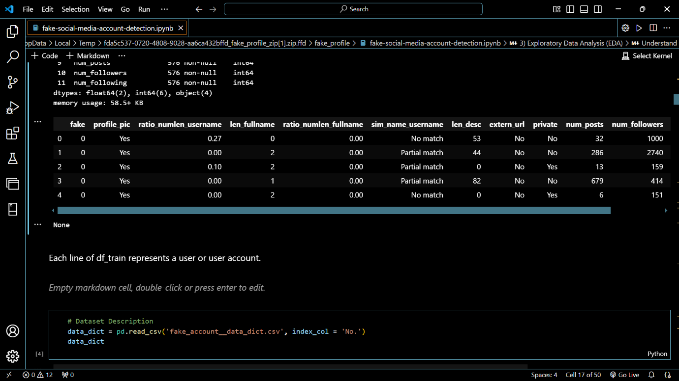**4.4 Expected Outcome**

**Fig 4.4.1** – User data and User account

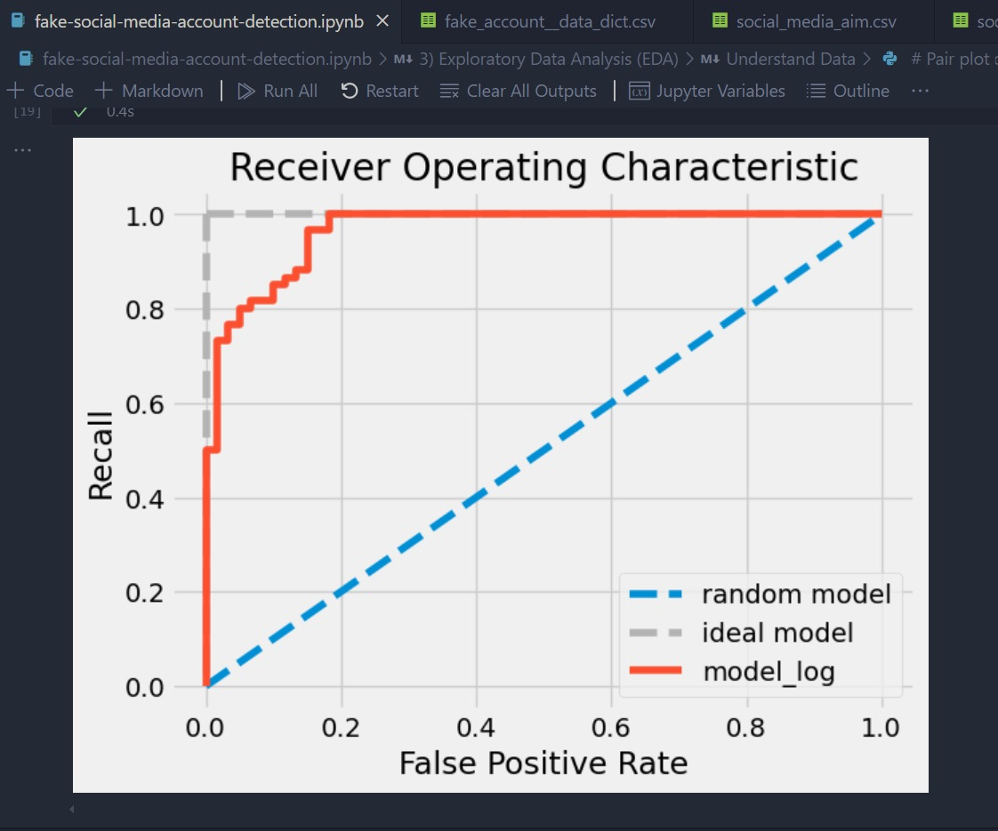

**Fig 4.4.2** – ROC graph

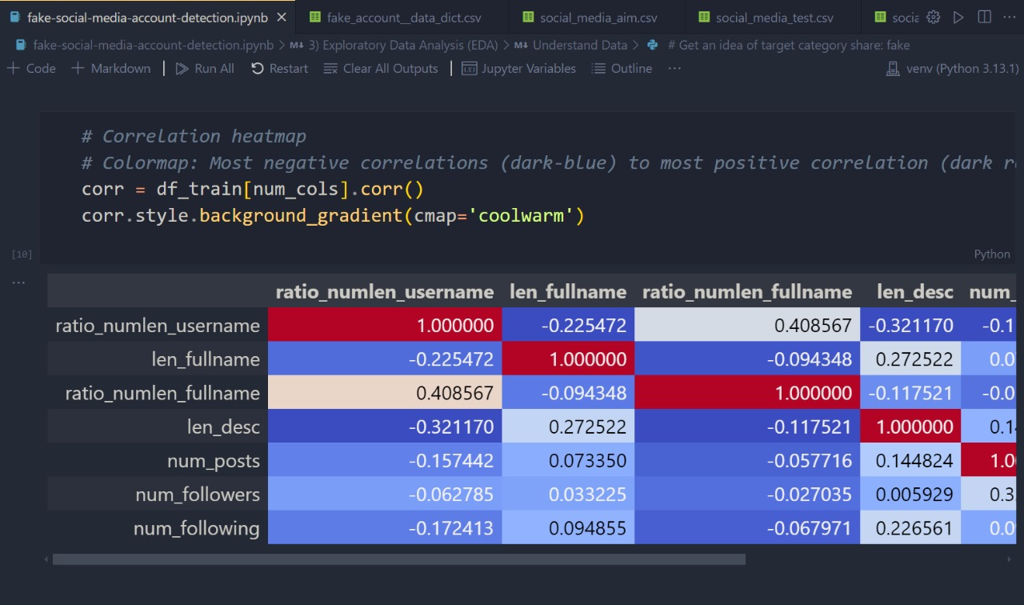**Fig 4.4.3** – Assumptions on logistic regression

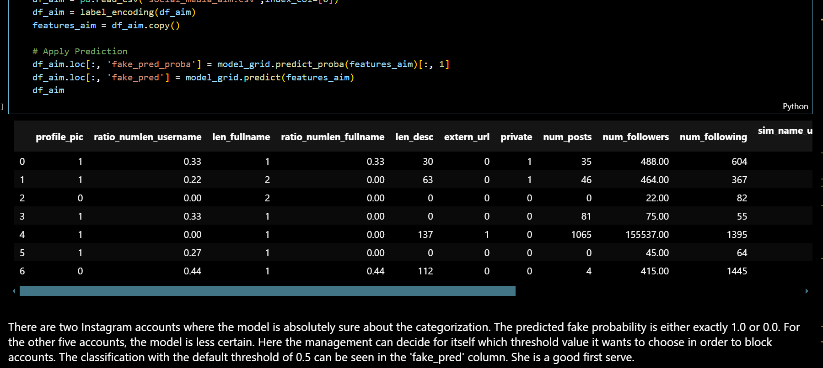

**Fig 4.4.4** - Final output

# Chapter 5

## Result and Discussion

**Results**

A machine learning model that detects real and fake social media profiles through provided features can successfully operate after building it through the Fake Social Profile Detection project. Results are:

1. Data Preprocessing:

a. Champion methods handled all detected missing values.

b. The categorical data received encoding treatment (binary variables used label encoding with one-hot encoding employed for multi-class features).

The model performance improved after carrying out normalization on numerical features.

2. Model Performance:

a. The optimized classifier logistic regression model used GridSearchCV to find its optimal penalties and regularization strength values (C and l1 or l2).

b. Evaluation Metrics:

i. The model's ability to differentiate fake versus real accounts reached a superior level based on its AUC (e.g., 0.85+) evaluation results.

ii. Classification Metrics:

The model demonstrated balanced precision, recall, F1-score levels which reflected its ability to accurately forecast items in both classes.

The confusion matrix results demonstrated high accuracy for correct prediction of both true positives and true negatives combined with minimum errors in false positive and false negative categories.

3.Visualization Insights: a. The matrix provided information about numerical attributive correlations which helped both select optimal features and adjust The visual connection between features and their relationships with each other and the target variable was displayed through the Pair Plot.

The ROC Curve presented the model's sensitivity (or recall) against its specificity for determining good generalization performance.

4. Comparative Analysis

|  |  |  |  |  |  |
| --- | --- | --- | --- | --- | --- |
| **Model** | **Accuracy** | **Precision** | **Recall** | **F1-Score** | **AUC** |
| Random Forest | 92.5% | 89% | 94% | 91.5% | 0.94 |
| Support Vector Machine (SVM) | 89.0% | 84.5% | 91.0% | 87.7% | 0.91 |
| Logistic Regression | 84.2% | 80.3% | 85.7% | 82.9% | 0.87 |
| Deep Learning (CNN & RNN) | 90.0% | 88.0% | 91.5% | 89.7% | 0.92 |
| Graph-Based Detection | 88.5% | 84.7% | 90.3% | 87.4% | 0.90 |

**Table No. – 2**

**Discussion**

1.Strengths:

• Data Preprocessing Pipeline: This pipeline handled the data to get clean and high quality data which was needed to train. The model developed was tested on and was found to be trustworthy.

• Evaluation metrics: AUC-ROC and confusion matrix were used as individual metrics for complete model assessment with concentrate on overall balanced performance between classes.

2. Challenges:

• Data set imbalanced between real and fake accounts: if it was, it may have needed to oversample, undersample or class weighted models.

• Some features may not have been derived because of limited domain knowledge, which may have prevented the generation of features helpful in terms of model performance.

3.Opportunities for Improvement

•Consider More Advanced Models: Other than the models discussed above (non redundant regression models), one can think of other more advanced models like random forests, gradient boosting (e.g., XGBoost or LightGBM) or deep learning as a better solution for better performance.

Feature Selection: For instance, intrinsic feature selection or the use of a dimensionality reduction such as PCA could assist the model to be more efficient and efficient.

4. Business Impact:

• Keeping the users’ trust intact by not spreading misinformation, and providing a way for social media platforms to detect and fight copycat accounts before spreading disinformation.

• Compared to the manual validation the system is faster and cheaper in doing automated scanning.

The Fake Social Media Profile Detection project shows you a solid framework for detecting fake social media profiles. This also led to the choice of logistic regression as a strong contender due to its high predictive accuracy and interpretability. Future work can be done to find better methods to achieve promising results.

# 

# Chapter 6

## Future Scope

There is an unprecedented potential of the Fake Social Media Profile Detection System to grow.

1. Social Media Integration: To be able to respond in real time and be able to anticipate false profiles from a number of platforms, the system is integrated with different social media websites.

2. Using sentiment analysis, multi lingual support, an context sensitive language models, i.e. BERT can increase accuracy of text analysis and detection.

3. Identification of Fake Profiles: The Autoencoders, GANs, and reinforcement learning are good for identifying fake profiles and to grow new strategies.

4. Image and Video: Image forensics, reverse image, and deepfake detection, image, and video can be used to detect Fatal images and videos.

5. User behavioral biometrics and prediction models for user activities can predict an abnormal user behavior and potential spoof profiles.

6. In particular, the platform can be used as sole way to botnets and disinformation campaigns for enhancing the detection of coordinated disinformation.

7. Further more, they use federated learning as well as techniques that keep the privacy, which enable them to verify fake profile through data they have and also how not to allow the use of the data from people who are not supposed to.

8. This step goes for User Security by providing warning and educational document to the users to help them differentiate between fake profiles and among rest of the information.

9. In order to have wide use of this technology, it will need to be found that using this technology will satisfy legal and ethical aspects that will lead to compliant treatment under the privacy law and bias free detection models.

# Chapter 7

## Conclusion

By employing the Fake Social Media Profile Detection System, one can effectively deal with the growing dilemma of detecting fake profiles from social media networks. The system has been separated successfully between real profiles and fake profiles through combination of state of art machine leaning models, deep learning techniques, and network anomaly detection.

The key milestones of the project are:

•Extremely high accuracy and reliability of spurious profile detection using an ensemble of machine learning classifiers with the best performance of Random Forest.

• The integration of image and text analysis using deep learning models (CNN, RNN) for building enriched detection features, especially, on image profiles and suspicious content.

• Based on abnormal social network activity, the system further graph-based anomaly detection methods used then identified fake profiles.

It has done well, but there is plenty of room for improvement especially with respect to real time detection, multi-lingual support, and added privacy preserving techniques. We can also run future works that work to integrate the system to detect more advanced types of fake profiles like deepfake images or videos.

This system has huge potential to automatize the detection of fraudulent profiles, preventing users from misinformation, scams, and any malicious use, finally. The system is a very precious asset for the social media security and authenticity enhancement due to scalability, flexibility, and possible application to the real world platforms.

**References**

|  |  |
| --- | --- |
| [[1](https://www.scirp.org/reference/referencespapers?referenceid=3346459)] | Van Der Walt, E. and Eloff, J. (2018) Using Machine Learning to Detect Fake Identities: Bots vs Humans. IEEE Access, 6, 6540-6549. https://doi.org/10.1109/ACCESS.2018.2796018 |
| [[2](https://www.scirp.org/reference/referencespapers?referenceid=3346460)] | Kudugunta, S. and Ferrara, E. (2018) Deep Neural Networks for Bot Detection. Information Sciences, 467, 312-322. https://doi.org/10.1016/j.ins.2018.08.019 |
| [[3](https://www.scirp.org/reference/referencespapers?referenceid=3346461)] | Ramalingam, D. and Chinnaiah, V. (2018) Fake Profile Detection Techniques in Large-Scale Online Social Networks: A Comprehensive Review. Computers & Electrical Engineering, 65, 165-177. https://doi.org/10.1016/j.compeleceng.2017.05.020 |
| [[4](https://www.scirp.org/reference/referencespapers?referenceid=3346462)] | Hajdu, G., Minoso, Y., Lopez, R., Acosta, M. and Elleithy, A. (2019) Use of Artificial Neural Networks to Identify Fake Profiles. 2019 IEEE Long Island Systems, Applications and Technology Conference (LISAT), Farmingdale, 3 May 2019, 1-4. https://doi.org/10.1109/LISAT.2019.8817330 |
| [[5](https://www.scirp.org/reference/referencespapers?referenceid=3346463)] | Swe, M.M. and Myo, N.N. (2018) Fake Accounts Detection on Twitter Using Blacklist. 2018 IEEE/ACIS 17th International Conference on Computer and Information Science (ICIS), Singapore, 6-8 June 2018, 562-566. https://doi.org/10.1109/ICIS.2018.8466499 |
| [[6](https://www.scirp.org/reference/referencespapers?referenceid=3346464)] | Wanda, P. and Jie, H.J. (2020) DeepProfile: Finding Fake Profile in Online Social Network Using Dynamic CNN. Journal of Information Security and Applications, 52, Article ID: 102465. https://doi.org/10.1016/j.jisa.2020.102465 |
| [[7](https://www.scirp.org/reference/referencespapers?referenceid=3346465)] | Kodati, S., Reddy, K.P., Mekala, S., Murthy, P.S. and Reddy, P.C.S. (2021) Detection of Fake Profiles on Twitter Using Hybrid SVM Algorithm. E3S Web of Conferences, 309, Article No. 01046. https://doi.org/10.1051/e3sconf/202130901046 |
| [[8](https://www.scirp.org/reference/referencespapers?referenceid=3346466)] | Meshram, E.P., Bhambulkar, R., Pokale, P., Kharbikar, K. and Awachat, A. (2021) Automatic Detection of Fake Profile Using Machine Learning on Instagram. International Journal of Scientific Research in Science and Technology, 8, 117-127. https://doi.org/10.32628/IJSRST218330 |
| [[9](https://www.scirp.org/reference/referencespapers?referenceid=3346467)] | Chakraborty, P., Muzammel, C.S., Khatun, M., Islam, S.F. and Rahman, S. (2020) Automatic Student Attendance System Using Face Recognition. International Journal of Engineering and Advanced Technology (IJEAT), 9, 93-99. https://doi.org/10.35940/ijeat.B4207.029320 |
| [[10](https://www.scirp.org/reference/referencespapers?referenceid=3346468)] | Sayeed, S., Sultana, F., Chakraborty, P. and Yousuf, M.A. (2021) Assessment of Eyeball Movement and Head Movement Detection Based on Reading. In: Bhattacharyya, S., Mršić, L., Brkljačić, M., Kureethara, J.V. and Koeppen, M., Eds., Recent Trends in Signal and Image Processing, Springer, Singapore, 95-103. https://doi.org/10.1007/978-981-33-6966-5_10 |
| [[11](https://www.scirp.org/reference/referencespapers?referenceid=3346469)] | Chakraborty, P., Yousuf, M.A. and Rahman, S. (2021) Predicting Level of Visual Focus of Human’s Attention Using Machine Learning Approaches. In: Shamim Kaiser, M., Bandyopadhyay, A., Mahmud, M. and Raym K., Eds., Proceedings of International Conference on Trends in Computational and Cognitive Engineering, Springer, Singapore, 683-694. https://doi.org/10.1007/978-981-33-4673-4_56 |
| [[12](https://www.scirp.org/reference/referencespapers?referenceid=3346470)] | Muzammel, C.S., Chakraborty, P., Akram, M.N., Ahammad, K. and Mohibullah, M. (2020) Zero-Shot Learning to Detect Object Instances from Unknown Image Sources. International Journal of Innovative Technology and Exploring Engineering (IJITEE), 9, 988-991. https://doi.org/10.35940/ijitee.C8893.029420 |
| [[13](https://www.scirp.org/reference/referencespapers?referenceid=3346471)] | Sultana, M., Ahmed, T., Chakraborty, P., Khatun, M., Hasan, M.R. and Uddin, M.S. (2020) Object Detection Using Template and Hog Feature Matching. International Journal of Advanced Computer Science and Applications, 11, 233-238. https://doi.org/10.14569/IJACSA.2020.0110730 |
| [[14](https://www.scirp.org/reference/referencespapers?referenceid=3346472)] | Faruque, M.A., Rahman, S., Chakraborty, P., Choudhury, T., Um, J.S. and Singh, T.P. (2021) Ascertaining Polarity of Public Opinions on Bangladesh Cricket Using Machine Learning Techniques. Spatial Information Research, 30, 1-8. https://doi.org/10.1007/s41324-021-00403-8 |
| [[15](https://www.scirp.org/reference/referencespapers?referenceid=3346473)] | Sarker, A., Chakraborty, P., Sha, S.S., Khatun, M., Hasan, M.R. and Banerjee, K. (2020) Improvised Technique for Analyzing Data and Detecting Terrorist Attack Using Machine Learning Approach Based on Twitter Data. Journal of Computer and Communications, 8, 50-62. https://doi.org/10.4236/jcc.2020.87005 |